Unit 8 Table Unification

Corey Crooks
Purdue University Global
IT234 – Leon King
July 7, 2021
Problem 1: Create a report of “seafood” and “produce” products, showing ProductID, ProductName, and CategoryName. Incorporate an inner join condition for this query. 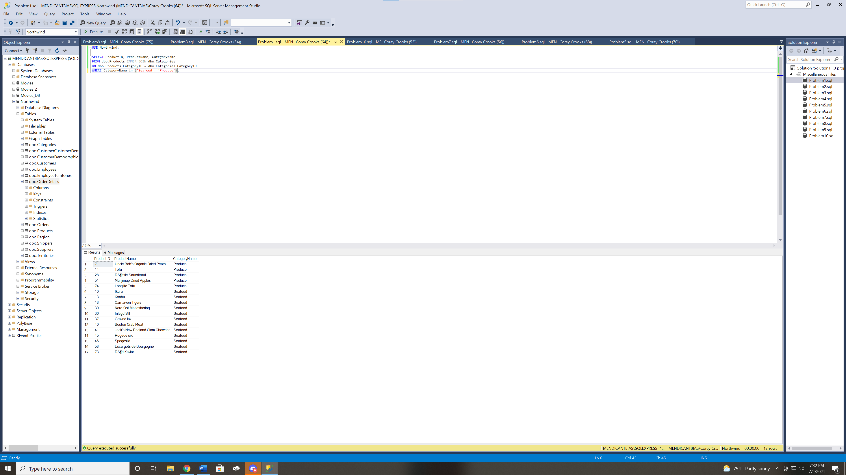
Problem 2: List the last name, first name, title, and salary of company employees with salaries above the company average. Use a non-correlated subquery in the SQL statement. 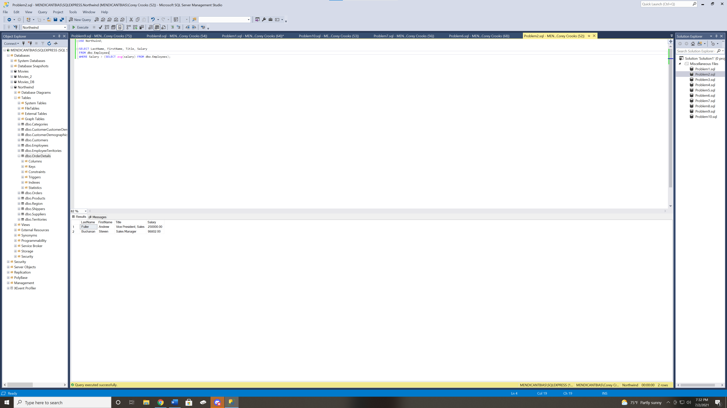
Problem 3: List the average salaries for employees in Seattle and London. The averages need to be calculated on a per city basis. Use a union operation to generate the results. (Hint: Use one SQL statement to calculate the average salary for one city and another almost identical SQL statement to calculate the average salary for the other city.) 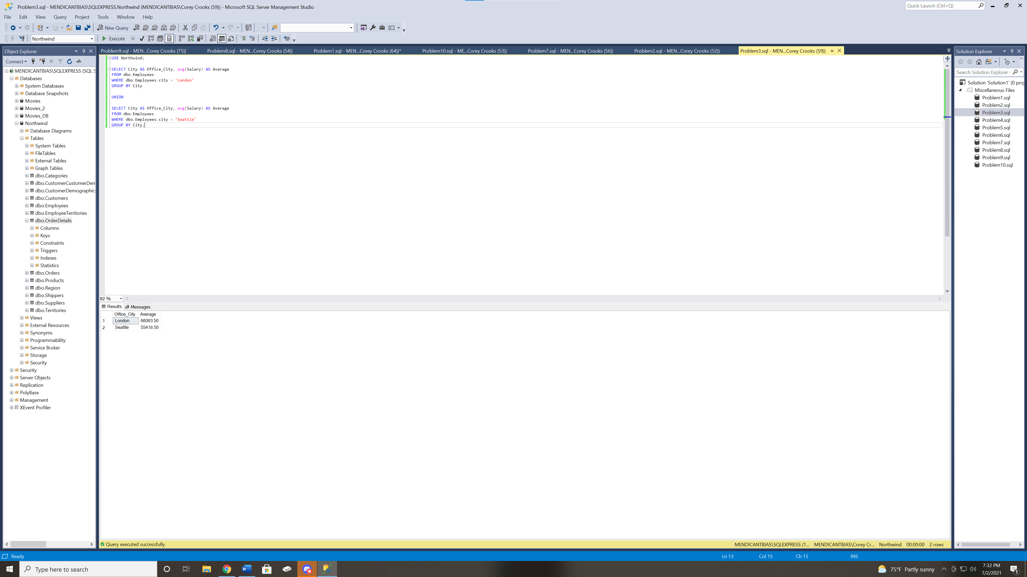
Problem 4: Show the product names for products that have been ordered in quantities equal to or exceeding 120. Use a non-correlated subquery in the SQL statement. 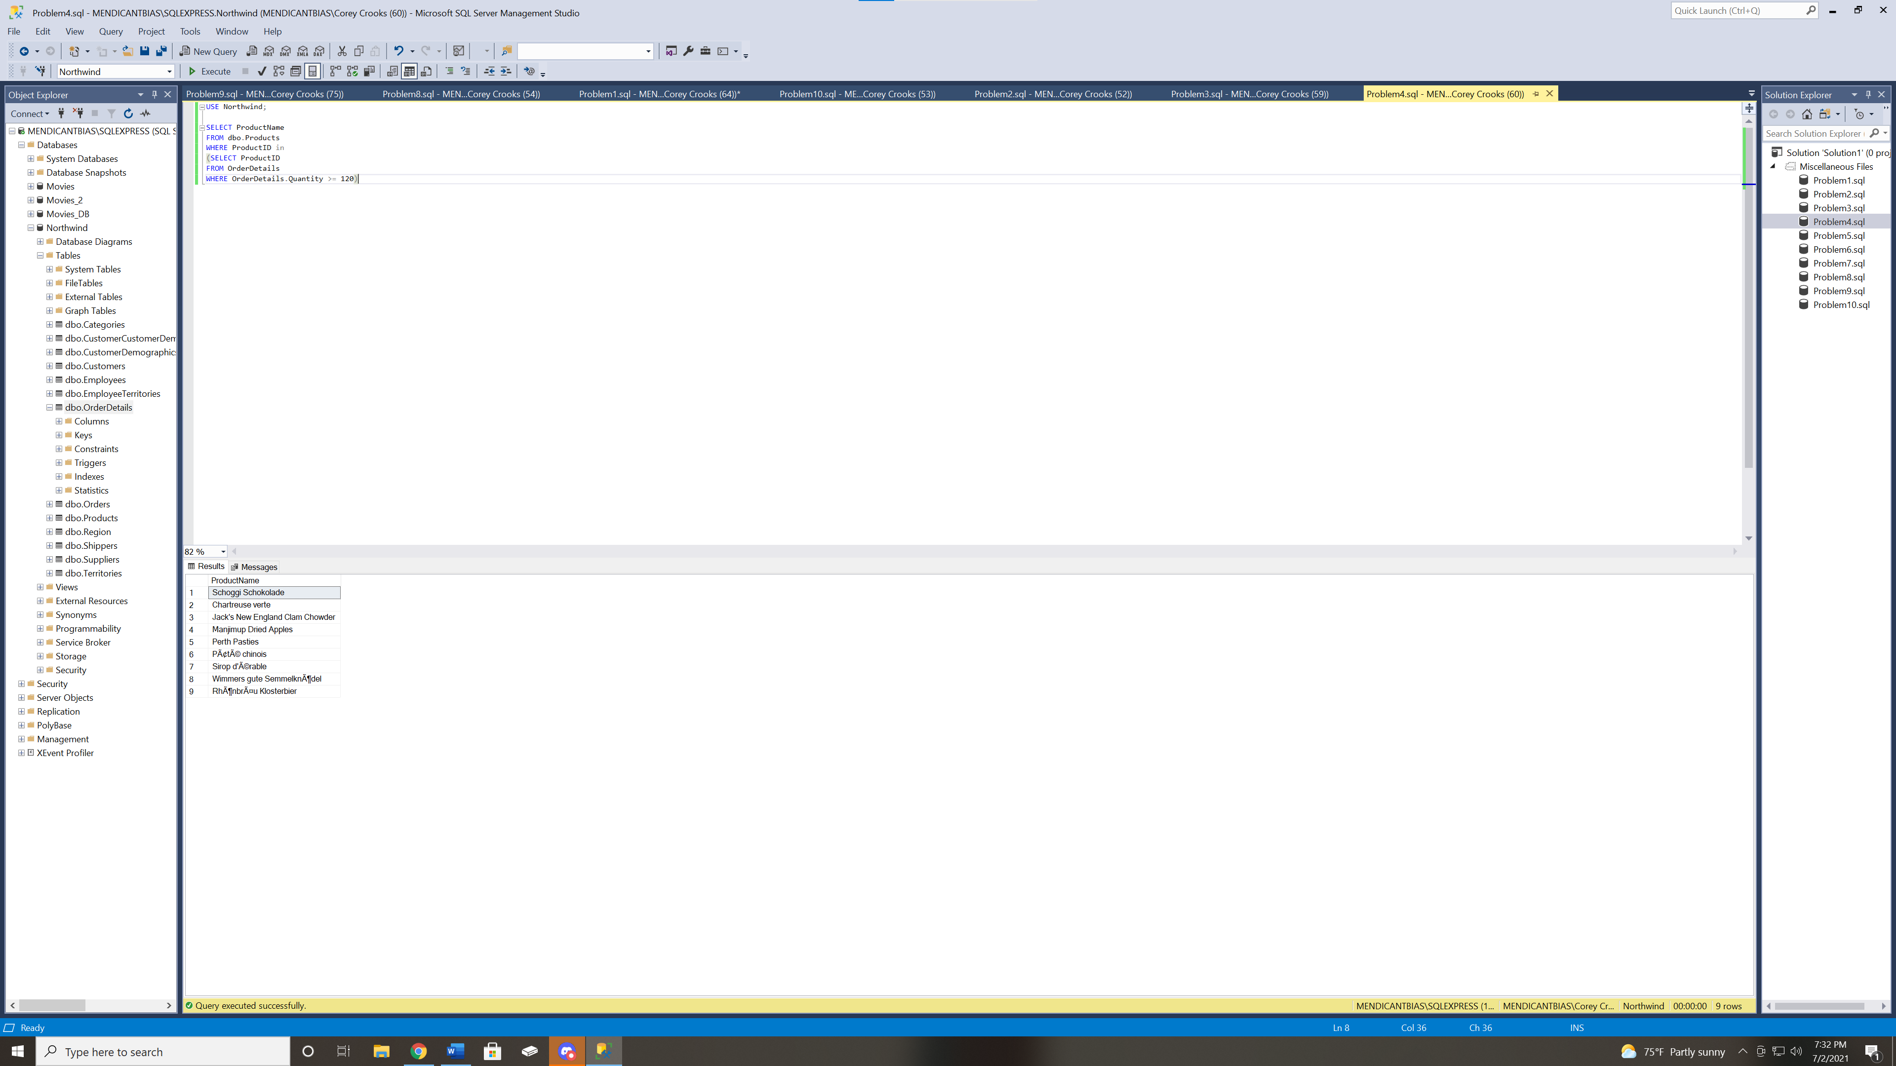
Problem 5: List the supplier names and cities for suppliers that reside in the same cities as Northwind employees. Use a non-correlated subquery in the SQL statement. 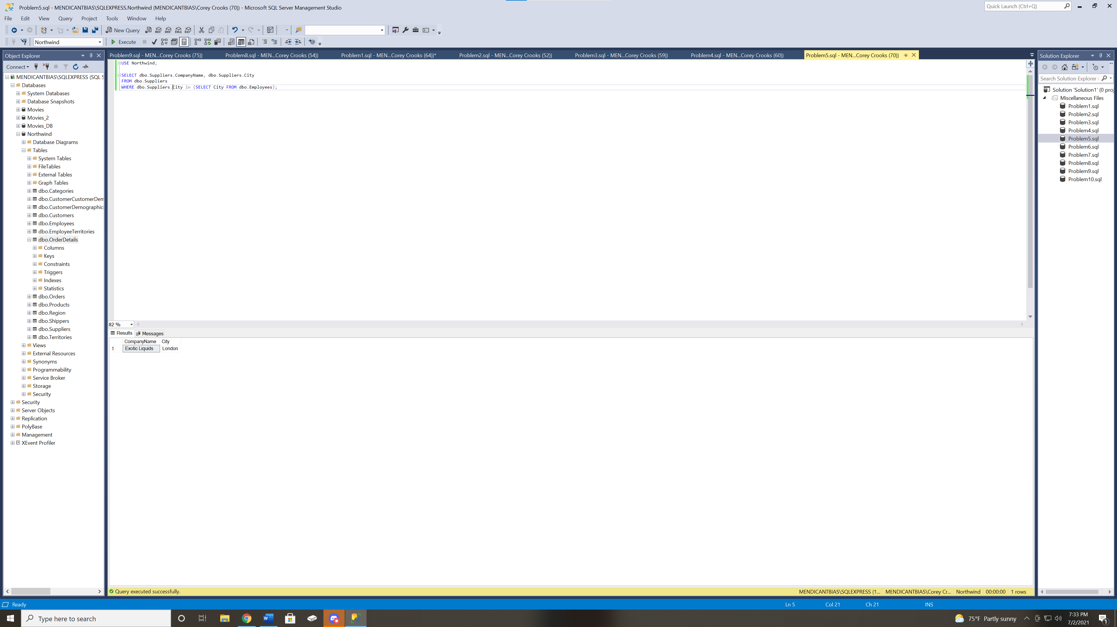
Problem 6: Display the names of Northwind employees that manage territories located in the Western region. Use inner joins in the SQL statement linking the Employees, EmployeeTerritories, Territories, and Region tables. Do not show duplicate employee names in the result set. 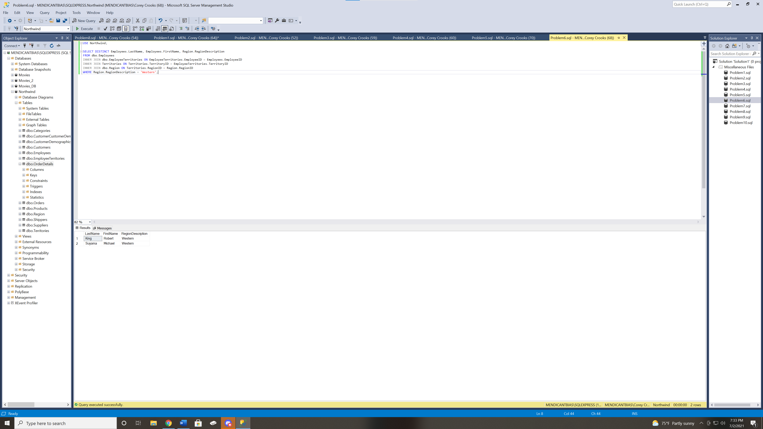
Problem 7: Display customer names, cities, and order IDs for customers residing in Madrid or Paris. Show all customers regardless of whether they have placed orders or not. Use an outer join in the SQL statement. 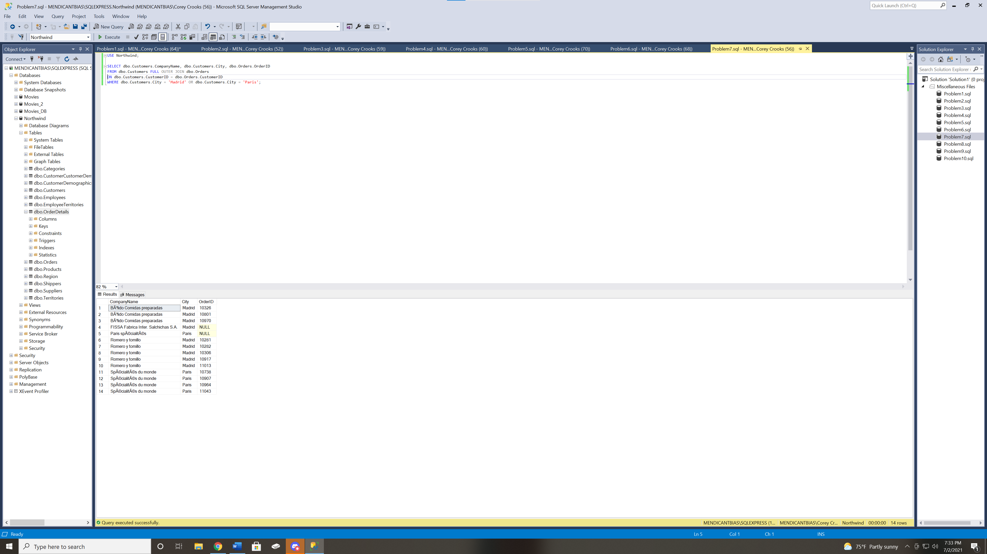
Problem 8: Display a combined list of supplier and shipper names along with their phone numbers. Use a union operation in the SQL statement. Present the results in alphabetical order based on CompanyName. 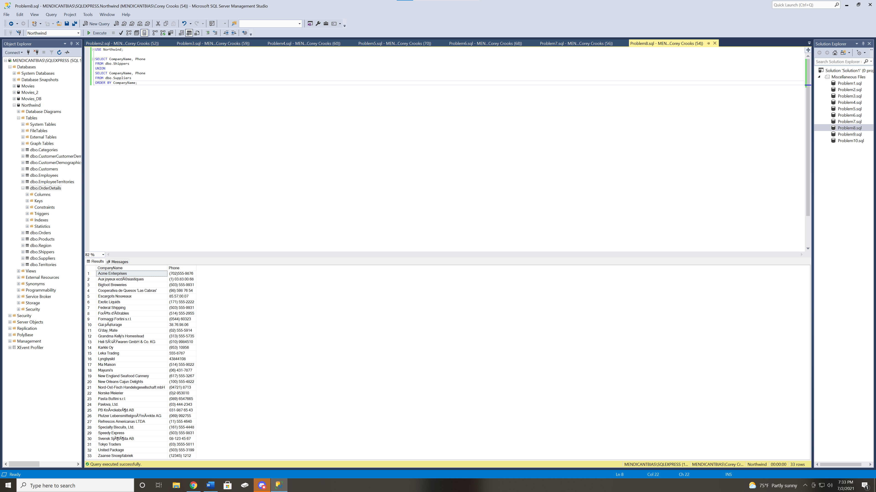
Problem 9: Show the employee names, salaries, and countries for employees that have salaries above the average salary within their respective countries. Use a correlated subquery in the SQL statement. 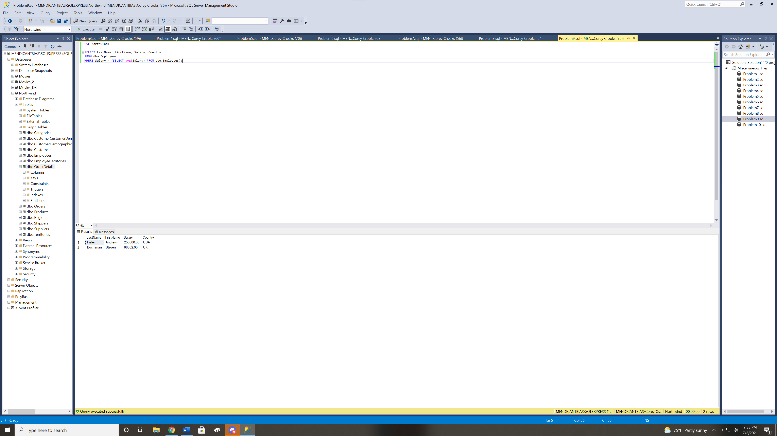
Problem 10: Display the names of products supplied by vendors in the USA and Norway. Show the product country in the result set. Present the results in alphabetical order by product name. Use an inner join in the SQL statement. 